Norfolk County Council Annual Report 2023/24

- 97.4% of highways inspections completed within timescale

- 96.8% of ‘Priority A’ defects (classified as dangerous/emergency) were fixed within the Transport Asset Management Plan timescales

- 95% Customer satisfaction (with Council Services)

- 96% of Looked after Children with an up-to-date Personal Education Plan

- Completed over 90,000 Adult Social Care Assessments for over 26,000 people

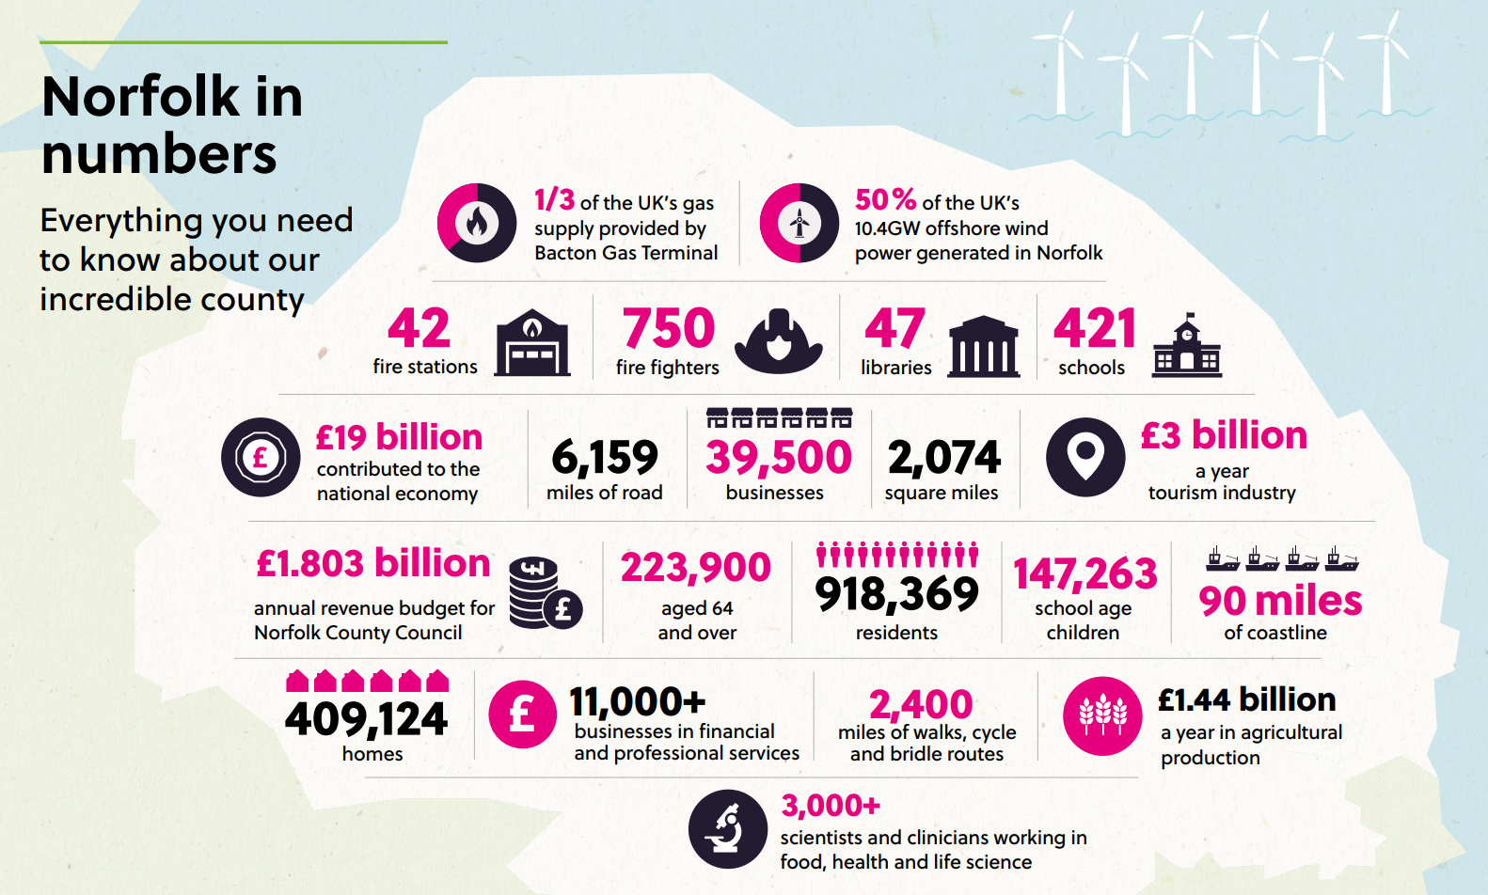

Council agrees £528m budget.
Councillors have backed a budget that "delivers for Norfolk", in the face of major challenges facing local government. Deputy council leader Councillor Andrew Jamieson, cabinet member for finance, told today's full council meeting that the budget would deliver for Norfolk. This is despite major cost and demand pressures facing all councils.
He said: "Our priorities are stable and sustainable finances, well delivered public services, economic growth and protecting and enhancing Norfolk's heritage and environment." Cllr Jamieson said it was a budget for the future, with an additional £60m for adult social services and £35m extra for children's services, and savings from transforming how the council operates. Cllr Jamieson pledged to continue to lobby the next Government for multi-year settlements, fair funding and reform of adult social care funding.
County Council leader, Councillor Kay Mason Billig, said the council would continue to be ambitious for Norfolk and had achieved many successes - against a tough economic backdrop. She said: "We know that our residents will be concerned about the decisions we make and how that may affect them. This year's budget has been one of the toughest to determine but we have a statutory duty to provide a balanced position, and that is what we are presenting to you."
The key headlines from the budget agreed today are:
- £122m of investment to meet demand and cost pressures next year - including £34.6m for inflation, £38m for legislative requirements, £39.7m for demand and demographic issues and £9.6m for policy decisions.
- £41.5m of new savings, including £9.6m from transforming how the council operates.
- A proposed 4.99% increase in the County Council's share of Council Tax, in line with the Government's capping level (2.99% for general Council Tax and 2% for adult social care). This would increase the Council's share of band D bills to £1,672.11. A 4.99% rise would generate £24.9m.
- A small number of the budget proposals have been identified as requiring consultation, as they may relate to a policy or service change. Cabinet will take decisions on these proposals in the summer, after considering the consultation results.

Councillors accept £600 million devolution deal.
County councillors have voted to accept a county deal devolution agreement with the Government, to transfer significant funding and powers to Norfolk.
Government funding will start transferring to Norfolk next summer, if councillors vote in July 2024 to stage the first election for a leader in May 2025. The deal will mean that decisions can be taken in Norfolk, for Norfolk.
The full council agreed the following recommendations:
Council:
- Recognises the work carried out during 2023 to consult with the public, inform Members and prepare plans in relation to the ‘in-principle’ County Deal brought to Council in January this year.
- Commends the work undertaken by the Leader and Officers to secure additional benefits for the Norfolk County Deal and resolves that the Deal should be accepted.
- Agrees that the election for the Directly Elected Leader should be held alongside the county council elections in May 2025 to enable the widest possible engagement with the electorate.
- Agrees that the resolution adopting the new governance arrangements should be brought to the Full Council meeting on 23 July 2024 to facilitate that election date.
For further details go to www.norfolk.gov.uk/norfolkcountydeal.
Background – what would a county deal mean?
Norfolk faces a major opportunity to gain new powers and funding from the Government, through an agreement called the County Deal. We could make more decisions in Norfolk, for Norfolk and secure investment of more than £600m over 30 years. If councillors agree the in-principal deal, it will enable us to invest in areas such as transport, skills and job opportunities, housing and regeneration, tailored to the needs of local people.
A County Deal would mean:
- Having a Council Leader who is directly elected by the public, enabling Norfolk’s voice to be heard by the Government.
- Targeting funding and resources to Norfolk’s own priorities.
- Unlocking housing and employment sites.
- Investing in the skills we need and attracting and retaining key businesses.
- Opening the door to more – further powers and funding in future

Norfolk County Council provided extra support to households this winter.
Earlier this year, Norfolk County Council announced it would receive further funding from the Department for Work and Pensions (DWP) to run the Household Support Fund until 31 March 2024. The Chancellor of the Exchequer announced in the Budget that this funding would be extended by a further six months.
The council has received £13.4m from central government and adding an additional £400,000 to make the total programme of support worth £13.8m. It is working closely with district, borough, and city councils, public sector partners to identify and implement a range of support measures to meet the needs of vulnerable households.
Norfolk’s roads and footpaths to be fixed as part of £4.51m funding.
Thirty-four roads and 20 footpaths across the County will be repaired by Norfolk County Council during this coming year as part of Government funding. Roads from Great Yarmouth to King’s Lynn, from Hunstanton to Thetford and many in between the entire County will receive reclamite spray or resurfacing along with footpath construction to ensure Norfolk’s infrastructure can best help people to get to work, travel to services and access Norfolk’s natural and cultural assets through effective highways maintenance.
Twenty-seven brand new gritters joined Norfolk’s fleet
Twenty-seven brand new gritters took to the roads for the first time later this winter in a £3,238,000 boost to the annual push to help keep Norfolk moving safely during the winter months.
Norfolk’s fleet of 58 winter vehicles treat 2,200 miles of roads on each full 3-hour gritting run. All A and B-class roads and some C-class roads are treated with a focus on commuter and major bus routes and as far as is possible one route into all villages. The A11 and A47 are gritted by National Highways.
In addition to the 49 gritting routes, several pedestrian areas and main pavements are treated in the centre of Norwich, Great Yarmouth and King's Lynn, and more than 2000 grit bins are available around the county for people to use on roads, pavements and cycle paths.
Find more information via www.norfolk.gov.uk/winter

Norfolk flood protection took centre stage in Westminster.
The threat posed by flooding and coastal erosion in Norfolk has been laid out starkly for MPs as Norfolk County Council has taken their case for change to the heart of Westminster. A delegation from Norfolk, led by Norfolk County Council Leader Cllr Kay Mason Billig and the Chair of the Norfolk Strategic Flood Alliance (NSFA), Henry Cator, met with MPs, on the 71st anniversary of the 1953 North Sea Flood, to explain the risks Norfolk faces and how those risks could be addressed.
As demonstrated over this winter, our county faces regular risks of flooding, with Norfolk ranked tenth most at risk of surface water flooding out of 149 local authority areas. In addition, the county's position on the North Sea exposes it to tidal threats as well as significant coastal erosion: without action, it's estimated that in North Norfolk alone approximately 1,030 residential and commercial properties could be lost to erosion by 2100. That number could be up to 10,000 in all of Norfolk.
These risks threaten both Norfolk residents and the contribution Norfolk makes to the wider country, as home to 54% of the offshore wind generation capacity in the UK and a major producer of food.
In a presentation delivered in Portcullis House, part of the Parliamentary Estate in Westminster, Norfolk's delegation made the case for MPs to:
- Push for legislative permission to build reservoirs designed to capture excess water in times of flood, for use in times of drought.
- Advocate for Property Flood Protection measures to be granted directly to the Lead Local Flood Authority (LLFA) for faster allocation for those who need it.
- Reduce bureaucracy by granting greater autonomy in funding allocation for surface water flood mitigation schemes.
- Combine enforcement and maintenance powers and responsibilities for LLFA’s.
- Support the creation of a dedicated Minister for the Coast.

£1 million boost for Highway Parish Partnership Schemes
Schemes totalling over £1m will be distributed across Norfolk to deliver the wants and needs of local parishes and residents as part of the Highway Parish Partnership.
The Parish Partnership scheme began in September 2011, when Parish and Town Councils were invited to submit bids for local highway improvements, with the County Council funding up to 50% of bid costs. The key benefits of the scheme are that it:
• Delivers local priorities identified by local people.
• Draws in additional funding for small scale highway improvements, enabling us to collectively deliver more schemes.
• Gives local communities an opportunity to directly influence the improvements in their local area. The programme continues to be well received by Parish/Town Councils, Local Members, and communities. Information about the number of bids received through the scheme over the past twelve years demonstrates there is a good spread across Norfolk.
A County Council contribution £467,884 and a Safety Camera Partnership contribution of £43,760 along with funding from Town and Parish Councils, will enable a programme of local works totalling £1,040,586 to be delivered.
For information on current schemes and if there are Parish Councils who wish to apply for future schemes then contact your County Councillor in the first instance. For further information please see https://www.norfolk.gov.uk/parishpartnerships

24/7 free travel to all disabled bus pass holders in Norfolk
From 1 February 2024 all Norfolk residents who hold a disabled concessionary travel pass will be eligible for free bus travel 24 hours a day, seven days a week when travelling within the county.
The decision, which was published today by Norfolk County Council, means that more than 14,500 people across the county who hold a concessionary bus pass due to disability, and their eligible companions, will now be able to travel on any bus at any time free of charge across Norfolk.
Previously concessionary pass holders with a disability were only able to travel for free on buses off-peak (all day on Saturdays and Sundays but only from 09:30 Monday to Friday) except for those registered blind or visually impaired.
Offering free travel at all times is over and above the minimum requirement set by government and is something that a local authority can choose to do but doesn’t have to do. The change was recommended following an updated equality impact assessment of the scheme which concluded that it is now unfair to offer a discretionary enhancement to just one group of disabled people (i.e. those who are blind or visually impaired).
The recommendation agreed by the individual cabinet member was to ‘extend the concessionary travel discretion of free travel at all times to all eligible disabled passholders and eligible companions, from 1 February 2024.'
The cost of providing this enhancement is estimated at £50,000 which will be funded by the Council’s ring-fenced public transport budget provided by the Department for Transport.
Householders can have free DIY waste disposal for small projects.
Norfolk residents have been able to dispose of small amounts of DIY waste at Norfolk’s Recycling Centres free of charge from 31st December following changes made by Norfolk County Council.
The change applies to small-scale projects carried out by householders on their own home, allowing them to bring a maximum 100 litres (must fit into 2 x 50l bags) for free or one single item (maximum size of 200cm x 70cm x 75cm). Each household is allowed four free visits with DIY waste every four weeks. Anything beyond this will still be charged at normal rates.
The change in policy follows Government abolishing charges for the disposal of limited amounts and types of DIY waste at recycling centres across the UK.
Prior to 31st December, customers with DIY-type construction and demolition waste will continue to be directed to the ‘Pay as you throw service’ which is available at all centres.
Traders must continue to pay for DIY waste. For more information visit www.norfolk.gov.uk/DIYwaste

Climate Strategy was launched at Gressenhall Farm and Workhouse Museum
Norfolk County Council’s Climate Strategy, adopted by Cabinet last May, was launched at Gressenhall Farm and Workhouse Museum with special guest Kate Strong, world record holder and endurance cyclist.
The Climate Strategy sets out how the council will work not only to reduce its own carbon emissions, but to drive down emissions across the county, protect the unique environment of Norfolk, and to seize the opportunities the move to a green economy represents, securing investment and growth for Norfolk.
Key proposals include:
- Supporting active and sustainable transport, including further bus improvements and electric vehicle charging
- Providing space for nature and developing a nature recovery strategy.
- Retrofitting council buildings to take out gas and oil heating and improve insulation – and encouraging businesses, residents and other organisations to do the same.
- Reducing emissions from the council’s companies, such as Norse.
- Developing the green economy, with support for green skills, sustainable tourism and businesses.
- The development of a nature recovery strategy to protect our natural assets and encourage greater biodiversity.
- Working with the Tyndall Centre for climate change research at the University of East Anglia, to understand climate change impacts and how Norfolk might adapt to them.
- Close collaboration between public sector, business, community and voluntary groups.
Award-winning Adult Learning service rated 'Good' by Ofsted.
Norfolk County Council’s Adult Learning has been rated as ‘Good’ following their latest Ofsted inspection. The inspection report praised the ambition of the service, which provides community-based and online learning for around 6,000 adults a year. The service achieved a ‘Good’ rating across all six areas that were inspected, alongside the overall ‘Good’ rating. Inspectors commented that learners are ‘highly motivated’ and committed to their studies. They praised the number of people who have a ‘clear plan’ for their future careers and that they want to improve their economic prospects.
Inspectors highlighted the work with residents of retirement homes who have increased their confidence, self-care and resilience after completing courses in basic cookery. They commented how, following the course, learners felt less isolated and ‘excited to prepare and eat their own meals’.
It was also recognised that the service has responded effectively to the growing demand for English for speakers of other languages (ESOL) courses.
There was praise for the work with Norfolk Fire and Rescue Service apprentices. The inspectors saw how the course helps them to work safely while learning about the importance of health and nutrition. The report concluded that the ‘apprenticeship is well matched to the needs of the fire service.’
This inspection result comes on the back of Norfolk County Council Adult Learning being named ‘Further or Higher Education Provider of the Year’ at this year's Norfolk Education Awards. This followed national recognition in 2021 where the service was named adult and community learning provider of the year at the Tes Further Education Awards.
Norfolk County Council Adult Learning offers a wide range of courses for adults of all levels and interests. Whether you want to change your career, improve your skills, or pursue your passion.
Find out more about Adult Learning and browse the course catalogue at www.norfolk.gov.uk/adultlearning.
Mark Kiddle-Morris.
Member for Necton and Launditch.
Norfolk County Council.

